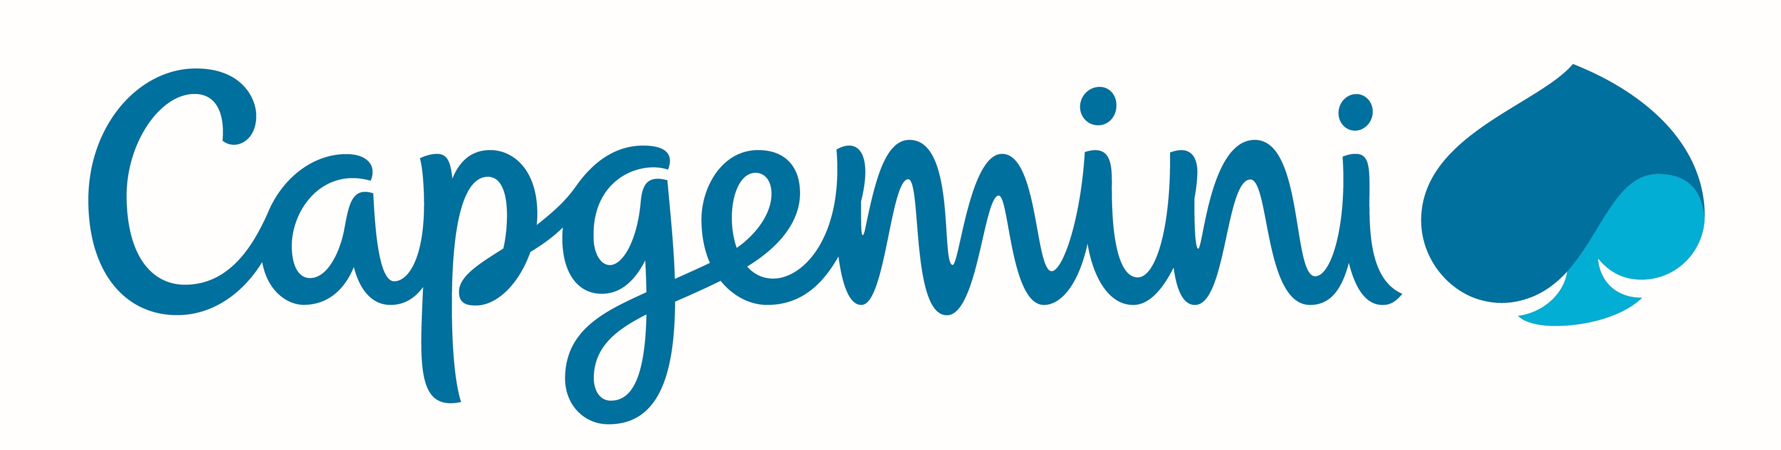

Sneha Awasthi
Professional Summary
Senior Software Engineer with 2+ years of experience in UI/Front-End Development and Mainframe DevOps. Had completed Bachelor of Computer Application(Management Faculty) in 2016. Possesses competent interpersonal and impeccable communication skills.

Skills Profile
Technical
Web Technologies | HTML5, CSS3, Javascipt, AJAX, Jquery, Bootstrap, SASS, JSON
Mainframe Technologies | JCL, CICS, COBOL, VSAM
Databases | MongoDB, DB2, MySQL, Oracle
Tools | Git, Jenkins, MS Office, Visual Studio Code, IBM Aqua, z/OS API Connect, Google Analytics, Notepad++, IDz/Rdz, IBM RSE, Apache Tomcat
Programming Languages | VBA, Batch Scripting, Basic Python, C
Additional | Excel Macros, VLOOKUP, Pivot Table, Formulas, Charting.

Functional
Training & Development | Soft Skills Training

Professional Experience

SENIOR SOFTWARE ENGINEER
Capgemini, India, September 2016 – Present

- Trained on Mainframe technology for 3 months.
- Worked on ADM Projects for Mainframe, Mainframe DevOps and UI.
- SSN Search - read customers’ data from VSAM files and then to write them to a different Output VSAM file using Mainframe Technologies like COBOL, JCLand CICS. Then the same files were used with little modification to fetch the data and send it to the API.
- Mainframe API using IBM z/Os connect tool with REST API and JSON format payload.
- API creation was done using z/OS Connect which fetched data from Mainframe and displayed the data on the page when the particular URL was triggered. There were various server side setups which were needed to configure the servers required for usage of z/OS Connect like Liberty server, Angel server, etc.
- Also worked on the UI development which included the use of Web technologies like HTML, CSS, Javascript, AJAX. The UI was created to display the details of one specific SSN in a tabular format. The SSN was to be entered in the search field and after submission, the API was triggered which “GET” the data to the webpage using AJAX. The data was systematically displayed.
- Prepared Elaborated Documents.
- Analyzed Clients’ business requirements and processes through document analysis and workflow analysis.
- Implemented Jenkins for automating the workflow. Complete DevOps CI implementation.
- Contributed towards coding Batch scripts (.bat files) for easing the file transfers and other basic functionalities between Mainframe and Windows.
- Part of EJB migration assessment for UK insurance client.
- Part of the consultative solutions team for UK insurance client to assess automation solutions for batch processing and config processes.
- Worked on automation using Excel Macros and VBA.

Training and Seminars
- Attended IBM conference in October 2018 that gave us details about upcoming IBM innovations including IBM z/OS Connect, IBM Zowe, etc.
- Online Training on Advanced Excel.
- Active participation in Capgemini IBM Blockchain Hackathon.
- Attended Tech Fiesta seminars by IBM, Adobe, etc.
- Classroom Training on Angular 2.
- Classroom Training on Agile for Developers.
- Attended IBM Developer Connect Lite at Pune in 2017 which introduced us to IBM Watson, IBM Cloudant, IBM Bluemix, etc.
- Received IDz/RDz Remote Training Sessions.
- Received training on Mainframe Technology for 3 months.
- Attended Seminar on Cyber Security at the college campus.

Certifications
- Google Analytics for Beginners.
- IBM Certified Database Associate-DB2-9 Fundamentals.
- Cyber Security Certification by Intelligent Quotients.

Awards and Recognition
- Received the Tech Rookie award from Capgemini in 2018.
- Top ranker of the entire batch of 2013-2016.

Education
- IMED, Pune, BVP University, B.C.A., 2016

